Title: Global contribution of violence to lifetime uncertainty

Authors:

José Manuel Aburto^{1,2,}*, Vanessa di Lego³, Ridhi Kashyap⁵,

Tim Riffe², Orsola Torrisi⁴, Alyson van Raalte²

[Auhors ordered alphabetically]

- Interdisciplinary Centre on Population Dynamics at University of Southern Denmark, Odense 5000, Denmark
- Max Planck Institute for Demographic Research, Rostock 18057, Germany.
- Wittgenstein Centre (IIASA, VID/ÖAW, WU), Vienna Institute of Demography / Austrian Academy of Sciences, Vienna, Austria.
- London School of Economics, London, UK.
- Oxford University, Oxford, UK.

*Corresponding author: jmaburto@sdu.dk

Abstract [250]:
Uncertainty around age at death, or lifetime uncertainty, is a key public health indicator and a marker of inequality in survival. By definition, violence and conflict are correlated to structural uncertainty in individuals’ lives, likely to influence the predictability of their lifespan. However, the relationship between violence and lifetime uncertainty in terms of survival has not yet been addressed. This study fills this gap by analysing whether and how violence influences the dispersion in ages at death, the metric most commonly used to measure lifetime uncertainty. Using mortality data by sex for 163 countries from the Global Burden of Disease Study and information on violence from the Global Peace Index between 2008-2017, we first find a strong positive correlation between levels of violence and lifetime uncertainty. In the Middle East, conflict-related violence is the most important cause-of-death contributor to lifetime uncertainty. In Latin American countries, this role is played by homicides and interpersonal violence. Our study further shows that, regardless of the type of violence, it overwhelmingly affects lifetime uncertainty at young ages. Although the effects of violence are larger in magnitude for men, the consequences remain considerable for adolescent girls and women in their early reproductive years. Overall, our study points at a double burden of violence on longevity: not only does violence shorten individual lives, but also makes length of life less predictable, with implications on individual life quality and population-oriented policy.

Main text [3500]:

Uncertainty about the future – survival in particular – is a fundamental aspect of human life, exerting a large influence on people’s behaviour. In any long-term decision-making process over the life course, individuals have to account for the level of certainty they perceive throughout their lives.. Most research on uncertain lifetimes, measured by an index of variation or spread in ages at death, focuses on how this unpredictability affects individual consumption and distribution of resources.¹⁻⁵ Recently, research has analysed how social determinants, such as education or income, affect lifetime uncertainty and found that socially disadvantaged groups tend to experience higher uncertainty in their age at death.⁶⁻¹¹ Exposure to violence – a fundamental state of vulnerability – is another social determinant of health, which can affect lifetime uncertainty with important social and psychological implications.¹² Furthermore, higher levels of uncertainty are linked to a greater likelihood of engaging in violent behaviour or conflictive predispositions as a way to respond to uncertainty (Rast, Hogg and Giessneer 2013; Kunst et al. 2018), making it a complex phenomenon with a feedback mechanism, where violence is linked to uncertainty and higher uncertainty may lead to violence. Violent environments are among the most common sources of uncertainty, together with other extreme negative life events, such as health issues, political instability and economic crises. Uncertainty-identity theory states that uncertainty concerning one's life and their place in the world affects perceptions about the future, precluding individuals to effectively plan (or see a meaning in planning) their lives, which in turn can lead to higher uncertainty at the aggregate level (Gøtzsche-Astrup 2020; Hogg 2014). In addition, violent settings affect population subgroups in different ways, with younger males experiencing more immediate and fatal consequences of violence, while women, children and older persons suffer a higher and long-term burden of non-fatal consequences that include physical, sexual and psychological abuse (Krug et al., 2002) and loss of economic or financial stability retained from a male family member lost to violence. There is also a greater misspecification of female deaths caused by partner violence, sometimes identified as accident, fall, or some other cause, which has been shown to be significant in contexts where overall levels of violence are higher. In areas with high conflict-related violence, deaths derived from extreme physical abuse such as rapes largely affect women and are inaccurately recorded. Children growing up in environments without the benefit of safety have lower levels of educational attainment economic productivity over their lifetimes and are more likely to be a perpetrator or victim of violence, creating a vicious cycle of “violence trap” (WHO 2009). Lastly, exposure to violence is also strongly associated with high-risk behaviours such as alcohol, drug abuse and smoking, which in turn are key risk factors for several leading causes of death, including cardiovascular disease, cancer, chronic lung disease, liver disease and other noncommunicable diseases. This implies that the toll of violence has a long-lasting outreach that go beyond the immediate consequences of premature violent death, and that its effects differ among population groups. Given that violence is among the most important sources of uncertainty, understanding the mechanisms through which one affects the other is of paramount importance. Further, greater uncertainty in life suggests insufficient or failing policies to protect individuals and indicates that health improvements at the societal level are not evenly distributed.
Although substantial effort has been directed at the interplay of perceptions of uncertainty at the individual level (or motivations) and collective or interpersonal violence (Stankov et al. 2010; Kunst et al. 2018; Gøtzsche-Astrup2020), the link between violence and lifetime uncertainty has not yet been comprehensively studied. We hypothesize that violence works as a key determinant of increases in lifetime uncertainty in contexts with ongoing conflicts and/or high levels of violence.
Globally, levels of lifetime uncertainty have declined over time, but vary considerably between countries.¹³⁻¹⁹ Most of this decline first came about from reductions in premature deaths, especially infant and maternal mortality, and mortality from infectious diseases.²⁰ More recently, reduced cancer and cardiovascular mortality has helped to reduce inequality in length of life within high-income countries.^{20,21} Lower life expectancy is usually associated with greater uncertainty.¹⁷⁻¹⁹
Studies relating violence to quality of life often rely on subjective measures.²² Fear of crime, for example, depends on how individuals perceive their environment and, therefore, might lead to a mismatch between the real uncertainty and how it is perceived.²³ Females are more likely to report significant levels of vulnerability in normal times, but experience lower levels of victimisation when violence increases.²⁴ Certainly, this has an immediate effect on quality of life,²⁵ causing higher levels of stress, anxiety and other mental health issues for individuals²⁶ while promoting segregation at the population level.^{24,27} Our aim is to complement such studies based on subjective quality of life indicators with an objective quantity of life measure of lifetime uncertainty to provide a more comprehensive understanding of the burden of violence on individuals and societies.

Here we study the relationship between lifetime uncertainty and violence and pose four questions seeking to fill the knowledge gap: How does lifetime uncertainty manifest itself in more violent countries? How does it compare with peaceful nations? How does this relationship compare between men and women? What is the contribution of violent deaths to the observed differences between violent and peaceful countries? To answer these questions, we use mortality data from 162 countries from the Global Burden of Disease Study (GBD) by sex (3072 life tables),²⁸ and information on levels of violence from the Global Peace Index (GPI) for the period 2008-2017.

Lifetime uncertainty and violence around the globe

One of the most challenging aspects of investigating violence-related phenomena at the global level is defining violence. There are many possible ways to define violence and due to its multidimensionality, what is considered an act that inflicts harm does not only vary culturally, but has also changed throughout history. We use the Global Peace Index (GPI) as an indicator of the level of violence in a country, since it is the only global indicator of violence available that accounts for the multifaceted feature of violence while considering country-specific conditions.²⁹ This index ranks the peacefulness of 163 (99.7% of the global population) countries based on three domains: 1) ongoing domestic and international conflict, 2) societal safety and security, and 3) militarisation. It is constructed using 23 indicators of violence, including the number and duration of internal conflicts, level of perceived criminality, and homicide rates.²⁹ Europe has consistently been the most peaceful region in the world over the last decade. By 2017, the most peaceful nations were Iceland, New Zealand, Portugal, Austria and Denmark. Conversely, the Middle East and North Africa region (MENA), represent the most violent zone,²⁹ while Latin America has the highest homicide rates in the world (Figure 1).³⁰ Syria, Afghanistan, Iraq, South Sudan and Yemen, in particular, were ranked as the most violent countries. These populations have all endured armed conflicts, which have inflicted a disproportionate toll on civilians.³¹⁻³³ Within Latin America, Colombia, Venezuela, and Mexico were the countries with the highest levels of violence. Venezuela and Mexico have undergone an unprecedented rise in homicides in the last decade due to political conflict and the war on drugs, respectively.^{12,30,34} Colombia has historically been a country with high homicide rates since the 1960s, although homicides have declined since 1996.³⁰
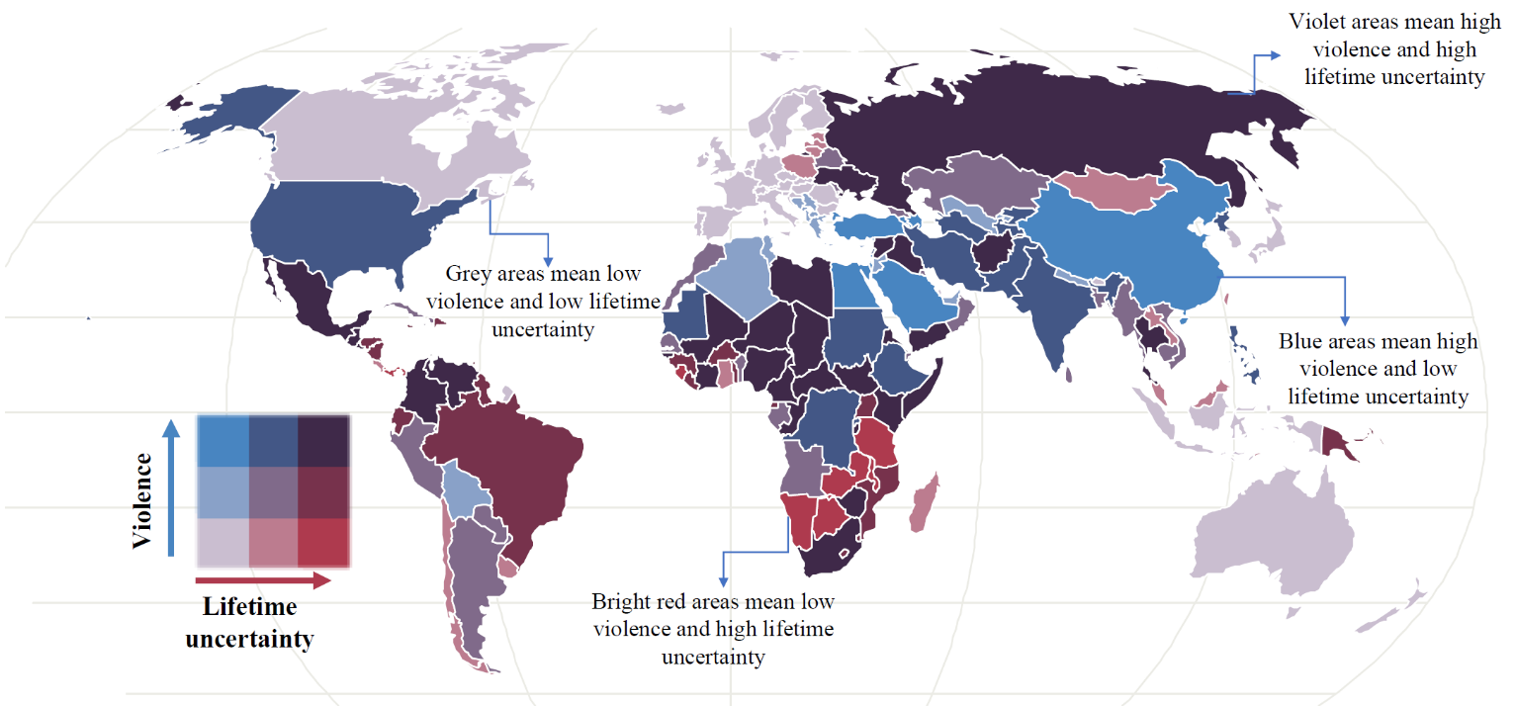
Lifetime uncertainty is measured using a summary index of the similarity in ages at death based from life tables. Multiple indicators exist for this purpose.³⁵ These include the standard deviation or the Gini coefficient of the age-at-death distribution. We use the standard deviation conditioned on surviving to age 10. There is a high correlation between these indices,^{14,35} and our results do not change substantially based on other indices.
Figure 1 Global level of violence and lifetime uncertainty for males in 2017

In Syria, Iraq, El Salvador, South Africa, and Venezuela, lifetime uncertainty is extraordinarily high for men and women (Figure 1, see Supplementary Material [SM] for females). This set of countries also share the highest levels of violence. Syria, for example, has been the most violent country in the world for the past five years, while El Salvador has presently the second highest homicide rate. In contrast, lifetime uncertainty is remarkably low in most countries of Northern and Southern Europe, where we also observe minimal to low levels of violence. The only slightly more peculiar cases are those of Italy, the United Kingdom and Tunisia, where lifespan uncertainty is low, but violence ranges from moderate to middle levels, allegedly due to more regionalised episodes of violence.
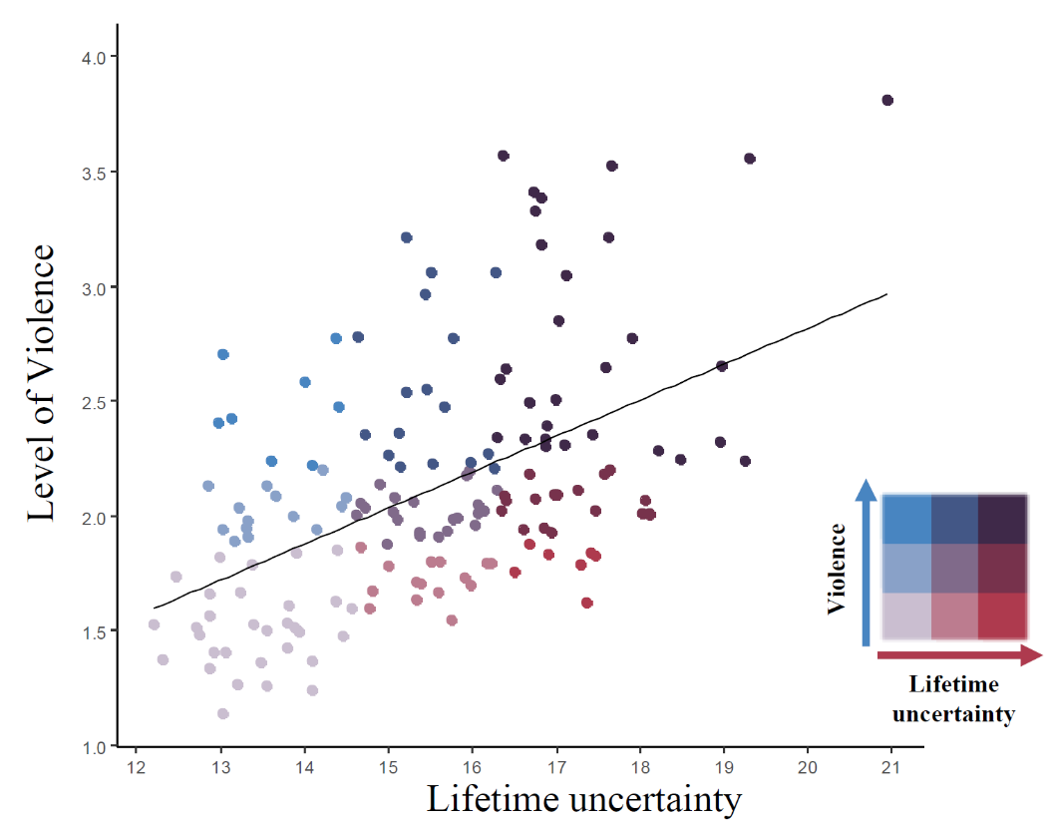
Peaceful countries all enjoy low lifetime uncertainty (Figure 2). The most violent instead tend to have higher lifetime uncertainty. Between 2008 and 2017, men and women living in the most dangerous countries showed a positive association with higher uncertainty in lifetime (correlation between level of violence and life uncertainty is 0.52 and 0.44 for men and women, respectively). Moreover, the strong relationship between lifespan uncertainty and life expectancy implies that those countries with high levels of violence experience lower levels of life expectancy than the peaceful ones.¹⁴ For example, in Mexico, after six decades of improvements, life expectancy stagnated after 2005 due to the rise in homicides.³⁴ During this period, lifespan inequality increased for the most violent regions of the country.¹² In Venezuela, life expectancy stagnated between 1996 and 2013, while lifetime uncertainty increased due to the rise in violence for men.³⁶ As of 2017, our results show that males in Syria and Afghanistan had a life expectancy at age 10 of x and y years respectively, while in Iceland and New Zealand it was z years, a gap of almost 14 years. [something about inequality or disparities?] This is important because lifetime uncertainty is a measure of how the length of life varies and the GPI measures the level of violence in a country. Although, in principle, the two indicators could be unrelated to each other – i.e. a peaceful country could suffer high lifetime uncertainty, while a violent country could show lower mortality and uncertainty in life – we consistently observe the highest levels of lifetime uncertainty in countries with the greatest levels of violence. This suggests that violent countries tend to have a double burden in terms of life expectancy and lifetime uncertainty: not only, on average their population live shorter lives, but also their life is less predictable. [more sociology here?] Israel is the only country which displays a different behaviour. Here, although measures of violence are relatively high, lifetime uncertainty is low.
Figure 2 The relationship between lifetime uncertainty and the level of violence in a country by in 2017 for males.
Lifetime uncertainty is lower for women than for men, and also correlates less with levels of violence (correlation of 0.44). We hypothesise that this difference results from higher mortality at young and working ages for males. This is usually referred to as the ‘young-mortality’ hump and it is an important explanatory factor of gender differences in mortality.³⁷ For example, war-related deaths are five times higher for men than for women, and homicide rates in Latin America are 10 times higher for men than for women.³⁸This highlights the importance of premature mortality on lifetime uncertainty in contexts of high violence. [more on this, see also outlook section Ridhi?]

Contribution of violent deaths to life uncertainty

To test our hypothesis of the ‘young-adult’ mortality hump, we compared the 25 countries with the highest levels of violence in 2017 with an average composed of the 10 most peaceful countries in the period 2008-2017. The former group includes countries like Syria, Iraq, Yemen, South Sudan, Somalia, Central African Republic, Libya, Venezuela, Colombia, Mexico and Afghanistan shown in Figure 3 (results for women and the full list of countries is shown in the SM). The latter includes, Iceland, New Zealand, Austria, Portugal, and Denmark. We identified the ages driving the difference in lifetime uncertainty between violent countries and more peaceful ones. We also analysed the contribution of homicides, war-related deaths, and other violent causes of death to lifetime uncertainty. These results represent a lower bound because violent deaths are often underestimated and underreported, especially in high-level violent settings. For example, in Mexico and Venezuela, misclassification, underreported murders, and the increasing number of missing individuals have made it difficult for researchers to estimate the current level of homicides.^{36,39} Similarly, the collection of credible/accurate data is particularly difficult in besieged and remote areas in Syria and Yemen.
Figure 3 shows the contribution of mortality by different causes to the difference in lifetime uncertainty between 18 violent countries and the 10 most peaceful countries between ages 10 and 60 years. The difference in lifespan uncertainty resulting from violence is remarkably high in the MENA region for both genders. For instance, violent deaths represent 91.4% and 55.7% of the difference for Syrian males and Iraqi females, respectively. In these countries, war-related violence contributes disproportionately to lifetime uncertainty as compared to homicides or other causes. This is especially true for young adult men. For instance, higher mortality in Syria for men aged 20-25 was responsible for 2.5 years of the xx excess years of standard deviation in age at death compared to the 10 most peaceful countries, while in Iraq and Yemen these ages contributed to a higher lifetime uncertainty by between 1 and 1.3 years. Here, as well as in African settings like the Central African Republic, Somalia and South Sudan, the female advantage is visible across almost all age categories; yet, lifespan uncertainty due to war-related deaths is higher for women approaching the start of their reproductive ages as compared to males in the same ages (about 0.8 for females and 0.5 years for males in Syria, 0.25 and 0.1 years in Yemen and 0.3 and 0.25 in Iraq). This suggests heightened vulnerability of adolescent females in contexts where war-related violence may come in the form of gender-related sexual violence and heightened maternal mortality due to limited access to obstetric care.⁴⁰⁻⁴²
The contribution of homicides to lifetime uncertainty dominates in violent contexts of Latin America. This region concentrates one third of global homicides.³⁸ Yet, age and gender-related patterns are substantially similar to countries experiencing war-type of violence. In Colombia and Mexico, lifespan uncertainty due to homicides is particularly concentrated among men aged 20-35. In Venezuela, the contribution of homicides is manifested even at younger ages, with lifetime uncertainty due to homicides for men aged 15-20 contributing more than one year to the standard deviation of ages at death. The impact of homicides is substantially more visible among men, although these still account for about 21, 14 and 11 percent of the total causes of lifetime uncertainty among Colombian, Mexican and Venezuelan women, respectively.
Overall, this analysis shows that violence in the form of armed conflicts and homicides has a substantial impact on lifetime uncertainty in populations. This impact on the unpredictability of life is overwhelmingly concentrated in young ages and predominantly influences lifespan uncertainty of men, confirming our hypothesis that gender differences are shaped by higher male violence-related mortality. It follows that countries with the lowest levels of lifespan uncertainty succeeded not only because of lower general levels of mortality at all ages, but also because deaths due to war or interpersonal violence in these contexts for both genders are almost inexistent. [what else can we say here]
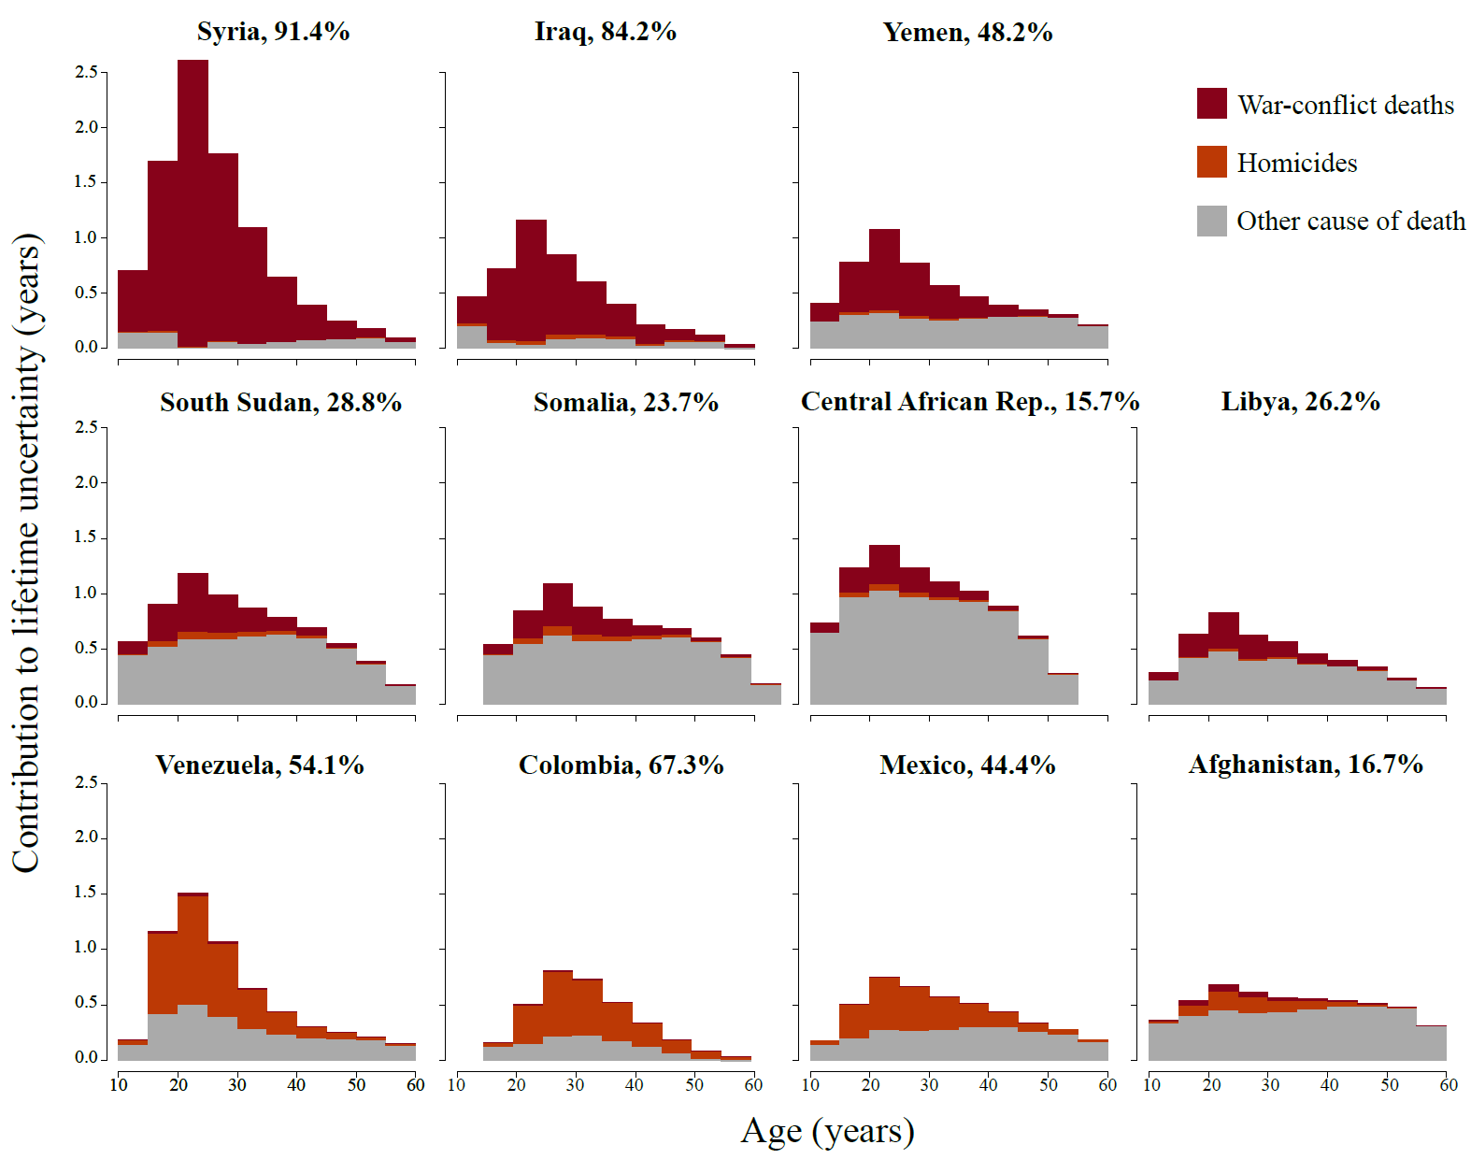
Figure 3 Contribution to male lifetime uncertainty by war-conflict deaths, homicides and other causes of death by age in 2017

Outlook
Conflict and non-conflict armed violence are a phenomenon plaguing various regions of the world, with many of the crises that erupted in the past decade remaining unresolved. This progressive fall in peacefulness is having impacts on individuals’ life chances and lifetime uncertainty, and has yielded lifespans that are both shorter and less predictable. This implies that countries with high levels of violence did not benefit from the dramatic increases in both life expectancy and in the predictability of length of life that most peaceful countries experienced in the 21st century. To put this in perspective, in the period 2010-2014, males in Honduras, El Salvador, Colombia, Venezuela, and Guatemala lost over two years of life expectancy due to homicides when compared to high-income and peaceful countries.⁴³ Similarly, the conflicts and crises in Egypt, Yemen, Libya, and Syria led to reductions in life expectancy. Life expectancy in Syria, for example, would have been 5 and 6 years higher for females and males respectively, had the crisis not occurred.⁴⁴
The double burden of lower life expectancy and higher lifetime uncertainty in contexts of high violence may be a precursor of indirect consequences on quality of life in violence-affected populations. This is because individual subjective capacity to assess how long she or he will live is instrumental when gauging the investment and consumption alternatives they have to better their everyday life. When this capacity is lacking due to increasing uncertainty in the surrounding environment, people’s expectations, decision-making and actions might be greatly hindered, impacting their overall life quality. [this discussion could be extended with some ref on quality of life depending on certainty about lifespan length]
Lifetime uncertainty is generally more pronounced among men than among women. This male-female difference raises questions about the nature and extent of differences in how individuals experience and survive violent conflicts as well as how they respond to socially mediated resources and risks in times of high levels of violence. Most combatants in armed conflicts and members of drug-cartels are men, so it is expected that men are the major direct victims of military operations. As a result women’s life expectancy usually appears less affected that of men in periods of crises.^{45,46} Nonetheless, from our analyses it emerges that lifetime uncertainty of women can also be highly influenced by violence in particular ages. In the MENA region, for example, peace and social order have been sharply deteriorated by years of civil violence. ^{47,48} At the same time, the increasing internationalisation of these armed conflicts and the consequent external military support, peculiarly in Syria and Yemen, have allowed warring factions to use highly sophisticated and more deadly weapons with huge collateral effects extending beyond combatants to women and civilians.³¹ Violence in the region has been further exacerbated by pre-existing widespread poverty, displacement and restrictions on livelihoods and increasing food insecurity.⁴⁹ All these factors not only have shaped lifetime uncertainty in these settings and contributed to the gap with more peaceful regions; they have also further magnified pre-existing structural patterns of disadvantage for women and fundamental imbalances in gender relations at young ages, thereby making young girls more susceptible to unpredictable lifespan duration.⁵⁰
In some Latin American countries homicide rates increased disproportionately.⁵¹In Mexico, male homicide rates more than doubled between 2007 and 2012.^{52,53} Male life expectancy thus declined between 2005-10.^{34,54} This epidemic of violence is related to specific policies trying to mitigate drug cartels operations and it has had unprecedented negative consequences in the last ten years of Mexico’s population health.⁵⁵⁻⁵⁸ Nonetheless, this has brought enormous consequences to women and their health. Over 31 thousand females have been victims of homicide in Mexico in the new century.⁵² Homicides are the ultimate form of violence, but living in violent environments or experiencing other types of violence brings health and social burdens, particularly for children and women.⁵⁹ For example, victims of violence are at higher risk of depression, alcohol abuse, suicidal behaviour, psychological problems, among others, over their life course.⁶⁰⁻⁶³ Even witnessing violence can affect individual wellbeing. Those who witness violence have higher rates of post-traumatic stress disorder, depression and are more likely to externalise behaviours.^{64,65}. Women who witnessed violent acts in particular are twice as likely to experience depressive and anxiety symptoms compared to those who did not witness violence.⁶⁶ Research has shown that living in and witnessing violence increases the normalisation of violence and acceptance of violent relationships for women even in the household. This in turn fosters the ‘cycle of violence’, extending it to family relationships, with further detrimental effects on lifespan uncertainty.
Describing the landscape of lifetime uncertainty and violence enabled us to reveal the link between these two central components in light of the increasing prevalence of violence in its diverse forms in today’s world. This is the first study to find a positive association between levels of violence and lifetime uncertainty in a global scale, and showed the power of analysing the consequences of violence using measures of uncertainty around the timing of death. Our study revealed that in contexts of high violence, lifetime uncertainty is linked to high premature mortality^{12,13,18} and that such early deaths are the driving factor behind the gap with peaceful nations. This link is likely governed by fundamental and complex psychological, sociological and biological factors, which can and should be further explored. In particular, our framework will yield further insights into the consequences of violence when applied to specific countries or subgroups within populations and may lead to new results if used to explore the effect of violence by socioeconomic status, education, or other social determinants of violence.
We might want to consider (From OT):
- A study on Peru’ found strong positive effects of exposure to civil conflict violence, especially during a woman's late childhood and early teenage years, on the probability of experiencing domestic violence as a wife. Furthermore, they also found that exposure to the civil conflict affects women’s attitudes towards violence: women who were more exposed to civil conflict violence are more likely to report that it is justified for men to beat women for various reasons. This suggests somehow a normalisation in the use of violence, even within the household, once under uncertain violent contexts.
See: Gallegos, J. V., & Gutierrez, I. A. (2011). The effect of civil conflict on domestic violence: the case of Peru. SSRN Electronic Journal.

- Another paper on Rwanda finds a positive, large and robust effect of conflict on the likelihood of experiencing domestic violence for women who married after the mass killings (La Mattina, G. (2013). Armed conflict and domestic violence: Evidence from Rwanda). Similarly, another study on sub-Saharan Africa uses diff-in-diff approach and finds that men and women who were exposed to conflict in childhood appear to express more acceptance of domestic violence. Women who experienced conflict during these ages were also more likely to report being a victim of domestic violence (La Mattina, G., & Shemyakina, O. (2018). Domestic Violence and Childhood Exposure to Armed Conflict: Attitudes and Experiences (No. 255). Households in Conflict Network.)

- On alcohol misuse, I am aware of a systematic review (predominantly of cross-sec studies) by Lo et al. who showed that research shows that men, people with higher cumulative trauma experiences, are significantly more likely to engage in harmful alcohol use compared to women when in conflict.
See: Lo, J., Patel, P., Shultz, J. M., Ezard, N., & Roberts, B. (2017). A systematic review on harmful alcohol use among civilian populations affected by armed conflict in low-and middle-income countries. Substance use & misuse, 52(11), 1494-1510.
Some other good references which are also presented in this systematic review are:
Roberts, B., Felix Ocaka, K., Browne, J., Oyok, T., & Sondorp, E. (2011). Alcohol disorder amongst forcibly displaced persons in northern Uganda. Addictive Behaviours, 36(8), 870–873.
Roberts, B., Murphy, A., Chikovani, I., Makhashvili, N., Patel, V., & McKee, M. (2014). Individual and community level risk-factors for alcohol use disorder among conflict-affected persons in Georgia. PLoS ONE, 9(5).

- A study on Sri Lanka analysed trends in alcohol misuse in non-conflict districts after the end of the conflict and found a rise in per capital alcohol consumption. They seem to suggest that the effect of conflict on negative health behaviours is influential even if one is not directly exposed, i.e. uncertainty matters even if you are not right on the conflict ground. Yet, note this study, as many of this kind is ecological, with all the fallacies that come with that.
See: Nugawela, M. D., Lewis, S., Szatkowski, L., & Langley, T. (2017). Rapidly increasing trend of recorded alcohol consumption since the end of the armed conflict in Sri Lanka. Alcohol and Alcoholism, 52(5), 550-556.

- A similar systematic review is also available for tobacco consumption, although much less definitive in terms of results.
See: Lo, J., Patel, P., & Roberts, B. (2016). A systematic review on tobacco use among civilian populations affected by armed conflict. Tobacco control, 25(2), 129-140.

- On tobacco, I know one paper on OPTs and Palestinians in general which showed that refugees in Syria and Palestine had higher odds of smoking as compared to refugees and non-ref in Jordan and Lebanon. They note that the former settings are much more prone to violent events than the others. Yet, the study is cross-sectional, so no prior info on prevalence before.
Jawad, M., Khader, A., & Millett, C. (2016). Differences in tobacco smoking prevalence and frequency between adolescent Palestine refugee and non-refugee populations in Jordan, Lebanon, Syria, and the West Bank: cross-sectional analysis of the Global Youth Tobacco Survey. Conflict and health, 10(1), 20.

- The study on contraception came out last week: https://onlinelibrary.wiley.com/doi/pdf/10.1111/sifp.12087 and you may also want to have a look at more discursive papers, e.g. Cange, C. W. (2016). The life course model as a framework for post-conflict health analysis: reflections on the Gulf War critical period. Medicine, Conflict and Survival, 32(4), 282-294.

Methods & Data [3000]

Data. We used mortality estimates for 163 countries from the Global Burden of Disease Study.²⁸ GBD is an observational epidemiological study widely used to analyse trends in mortality and morbidity from major diseases, injuries and risk factors in a global perspective. These data are provided in 5-year age intervals with the highest interval concentrating deaths above age 85. We focus on three main causes of death related to violence Table 1 for code of the International Classification of Diseases [ICD10]): 1) homicide, 2) other violence (mostly war, state, and terrorist), and 3) all other causes.

To measure the levels of violence (or peacefulness) we use the Global Peace Index (GPI). GPI has been systematically calculated in the period that we study 2008-2017.²⁹ It ranks the 163 countries according to the level of peacefulness. It is based on 23 qualitative and quantitative indicators that measure the state of peace using three domains: the level of societal safety and security, the extent of ongoing domestic and international conflict, and the degree of militarization. It is the most comprehensive index at a global scale and, therefore, a primary source of this study. The R-code to get the data is available at [URL].

Demographic methods. To more accurately measure the age-at-death distributions for each country we ungrouped the 5-year age intervals to single ages and distributed the deaths above age 85 with the penalized composite model assuming that deaths follow a Poisson distribution and calculated age-specific mortality rates.⁶⁷ We constructed life tables for each country, sex, and year following standard demographic techniques.⁶⁸ From these, lifespan uncertainty conditional on surviving to age 10 were calculated.

To disentangle the effect of violent deaths we calculated life expectancy and lifespan uncertainty in absence of these following the cause-deleted life table methodology.⁶⁸ Additionally, we decomposed the difference in lifespan uncertainty between violent countries and RPR using the linear integral model for decomposition.⁶⁹ All procedures were done using the R software,⁷⁰ and are fully reproducible from the public repository [URL].

Life span uncertainty indicator. Several indices, highly correlated, to measure lifespan uncertainty exist.^{35,71} We chose the standard deviation of longevity conditional on surviving to age 10. This indicator has the advantages of being widely used as dispersion indicator in statistics, easy to interpret, decomposable into age- and cause-specific components, and is expressed in years. In life table notation the standard deviation () is given by
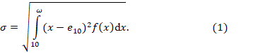
Where and denote the age-at-death density function, life expectancy at age 10, and the open-aged interval (110+ in our case), respectively. We condition to age 10 to capture the onset of violent deaths, which [x%, Tim?] occur over this age, and because infant mortality conceals mortality dynamics of adult ages.⁷²

Robustness check with life disparity. All figures were replicated using “life disparity” or average life lost. This indicator has been used in several lifespan uncertainty studies, including one focusing on homicide mortality.¹² The indices differ in their sensitivity to changes in mortality and in properties and is measured in years, allowing a direct comparison with the standard deviation. While some variations in the levels of lifetime uncertainty were observed, the main results and conclusions of our study are supported.

Robustness check conditioning on surviving to different ages.

Selection of violent countries and construction of the robust peaceful region (RPR). We focus on the worst and best performers of GPI to compare the burden of violence on lifespan uncertainty. The “Best Performers” category includes all countries that ranked in the top ten over the period 2008-2017: Australia, Austria, Belgium, Canada, Switzerland, Czech Republic, Denmark, Finland, Ireland, Iceland, Japan, Norway, New Zealand, Portugal, Singapore, Slovenia and Sweden. The “Most Violent” category includes the 25 worst performers countries that scored a low or very low level of GPI in 2017. [Let’s create a table with both the peaceful, violent and life uncertainty levels, gpi] To have more robust comparisons of lifetime uncertainty between violent countries and a peaceful environment, we constructed a “Robust Peaceful Region” based on the best performers of GPI. It was determined by the weighted mean of age-specific death rates by sex of the Best Performers. The weights were constructed according to the instances each country appeared in the top ten.

Acknowledgements:

Author contributions:

Competing interests: Non-declared.

References [50]

